How to download the Hamelin et al., 2023 project data
on ALICE HPC.
By: Bashar Al-Smadi

Step1: Download Data from GEO (GSE202695)

1. Navigate to GEO: Go to the GEO homepage by entering the URL: https://www.ncbi.nlm.nih.gov/geo/
2. Search for the Dataset: In the search bar, enter the accession number "GSE202695" and press enter.
3. Download Dataset Files: the page lists several processed data files available for download:

GSE202695_CCcorrected_logcounts.csv.gz - Corrected log-transformed count data.
GSE202695_counts_afterQC.csv.gz - Count data after quality control.
GSE202695_counts_raw.csv.gz - Raw count data.
GSE202695_metadata.csv.gz - Metadata file.

To download these files, you can use the links provided next to each file. By pressing FTP next to each file.

Step2: Download Raw Data from SRA (PRJNA837007) On ALICE HPC.

1. Open NoMachine on your laptop and log in into ALICE
2. Open firefox in Alice and Navigate to SRA Run Selector: type in the Accession ‘PRJNA837007’. Or go directly to this link:
https://www.ncbi.nlm.nih.gov/Traces/study/?acc=PRJNA837007&o=acc_s%3Aa

3. Download the Accession list: file will be downloaded called SRR_Acc_List.txt

4. Open the terminal on ALICE and log in using:
ssh -X YOUR_USERNAME@alice.le.ac.uk

5. Go into your Scratch directory by :

cd $SCRATCHDIR

6. Create a new directory in any name, just to save the files in it:

mkdir SRP

then enter it:

cd SRP

7. Copy file path and write it on the file explorer

simply type pwd in the terminal and press Enter. And copy the path
after that paste it on the top of the file explorer by pressing on
like the below screenshot in my case:
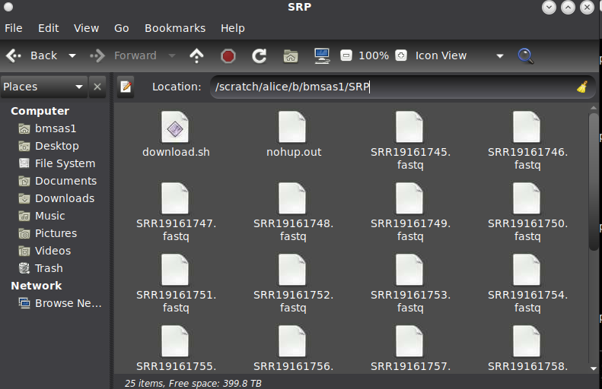

8. Drag the Accession file into the new directory. Drag it or copy it there (the SRR_Acc_List.txt file will be in Downloads).

9. Create a Bash Script: I wrote a bash script to download all of the files and convert them to fastq. just right click on the file explorer to your SRP directory and create a new file in the name of download.sh’ open it and copy the following script into your editor. And then save it.
```
#!/bin/bash

# Loop through each accession number in the file
while read -r SRR; do
echo "Processing: $SRR"

# Download the .sra file
echo "Downloading .sra file for: $SRR"
prefetch $SRR

# Convert the .sra file to FASTQ format
echo "Converting to FASTQ: $SRR"
fasterq-dump $SRR

# Remove the directory and .sra file
echo "Cleaning up: $SRR"
rm -rf $SRR

done < SRR_Acc_List.txt

echo "All downloads and conversions are complete."
```
10. Go back to ALICE terminal and load the SRA Toolkit, it is already downloaded there:

module load sratoolkit/3.0.0-5fetwpi

then run to configure it:

vdb-config --interactive

a blue screen will appear just press x to exit it.

11. Running the Script:
Run the script using:

nohup bash download.sh &

This command (nohup) runs download.sh in the background. Output is redirected to nohup.out by default, so you can check the progress by viewing this file. Please refresh your file explorer and check if the files are downloading, if not check if there is an error message in the nohup.out file.

IF EVERYTHING IS GOOD, YOU CAN EXIT ALICE (BUT DO NOT TERMINATE, INSTEAD DISCONNECT) AND SHUTDOWN YOUR COMPUTER AND IT WILL STILL KEEP DOWNLOADING, KEEP ENJOYING LIFE NOW. THANK YOU.
Come back later to check if all is completed without errors, and run another bash script ‘check_downloads.sh’ it is in the troubleshooting section to check if all files are downloaded.
-----------------------------------------------------------------------------------------
Troubleshooting
- Bash script to check if all files are downloaded : I wrote a bash script to check if all files are downloaded successfully and if it found a missing file, it will print it on the terminal. like the first bash script: just right click on the file explorer to your SRP directory and create a new file in the name of ‘check_downloads.sh’open it and copy the following script into your editor. And then save it.
#!/bin/bash

# Loop through each accession number in the file
while read -r SRR; do
# Check if both paired-end FASTQ files exist
if [ ! -f "${SRR}_1.fastq" ] || [ ! -f "${SRR}_2.fastq" ]; then
# If either file is missing, print the SRR accession number
echo "Missing files for: $SRR"
fi
done < SRR_Acc_List.txt
echo "Check complete."
and then go back and run it in the terminal using:
bash check_downloads.sh

- Stopping the bash script: if anything went wrong and the bash script is still running in the background. You can kill it by:
ps aux | grep '[d]ownload.sh'

then, kill the process number if its there, like this example in my case:

